SHAHEED BHAGAT SINGH STATE TECHNICAL CAMPUS
Moga Road, NH-95, Ferozepur -152004
(Established by the Punjab Government)
(Formerly Shaheed Bhagat Singh College of Engineering & Technology)

STORE AND PURCHASE SECTION
Manual for performing operations in PnI application of TCSiON
(For Individual Department)

Table of Content

Sr no | Topic | Page No
1 | Request for issue of items from Central Store by individual dept.  (Dept. -> CS) (RAISE INDENT) | 2
2 | Purchase process by the Deptt
a. | Raising Purchase Requisition (PR) | 3
b. | Quotation Management | 4
c. | Purchase Order (PO) | 5
d. | Good Receipt Note (GRN) | 6
3 | Procedure for repair/service of equipments in TCSiON | 7

Abbreviations used: IO -> Indent Originator, DSPO -> Dept. Store & Purchase Officer

- Issue of items from Central Store (Dept. -> CS)
Request for issue of items by dept. from the Central Store (RAISE INDENT)
  - Workflow
IO ->HoD -> Rampal
  - Dept IO will raise indent
Click
-> Procurement and inventory -> inventory -> Raise Indent - > Create
Select Source Site as respective Department.
Destination Site as EW (for central store)
  - HoD can approve/reject the indent raised by IO.
  - After approval from HoD, Indent will move to the Central Store (Mr Rampal).
  - Mr Rampal will issue items if available, otherwise purchase process will be initiated by Mr Rampal.
  - After completing the purchase process, Mr Rampal will issue items to the IO of dept.
  - IO can further issue or consume items to staff members of deptt.
by clicking
-> Procurement and inventory -> inventory -> Consumption & Issue- > Create

- Purchase process by the Deptt
  - Raising Purchase Requisition (PR)
    - Workflow
IO-> DSPO -> HoD -> HoD
    - IO will initiate the PR
Click
-> Procurement and inventory -> Precurement -> Purchase Requisition - > Create
Select Source Site and Destination Site as respective Department.
    - After Submission, it will move to DSPO.
DSPO can approve/reject the PR
    - After approval from DSPO, PR will move to login of the HoD
The HoD can approve/reject the PR
    - After approval from the HoD , PR will remain in the login of the HoD. He will repeat the process of approval.

  - Quotation Management
    - Workflow
IO-> DSPO-> HoD-> HoD
    - IO will initiate the Quotation process (Manual Quotations)
Click
-> Procurement and inventory -> Precurement -> Quotation Management - > Approve Vendor Quote
    - After Submission, it will move to DSPO.
SPO can approve/reject the Quotations Vendor Quote.
    - After approval by DSPO, Quotations Vendor Quote will move to login of the HoD.
    - After approval from the HoD, Quotations Vendor Quote will remain in the login of the HoD. He will repeat the process of approval.

  - Purchase Order (PO)
    - Workflow
IO-> DSPO -> HoD
    - IO will initiate the PO
Click
-> Procurement and inventory -> Precurement -> Purchase Order - > Create
- After Submission, it will move to DSPO.
SPO can approve/reject the PO.
- After approval by DSPO, PO will move to login of the HoD
The HoD can approve/reject the PO.

  - Good Receipt Note (GRN)
    - Workflow
IO -> DSPO
    - IO will initiate the GRN
Click
-> Procurement and inventory -> Inventory -> Inwards -> GRN -> Create
- IO will scan and upload Inspection Note.
- After Submission, it will move to DSPO.
- DSPO can approve/reject the GRN.
The inventory will be updated after approval by DSPO.

- Procedure for repair/service of equipments in TCSiON
For repair/service of equipments, the process will be similar to purchase process for item except few changes.
General procedure for repair/service of Items by the Central Store in TCSiON will involve:
  - Raising Purchase Requisition (PR) for repair/service in TCSiON
  - Quotation Management in TCSiON
  - Purchase Order (PO) for repair/service in TCSiON
  - Good Receipt Note (GRN)
The procedure for repair/service will be similar as described for items in section 2 except following changes:

While raising PR, select services instead of items as shown below:
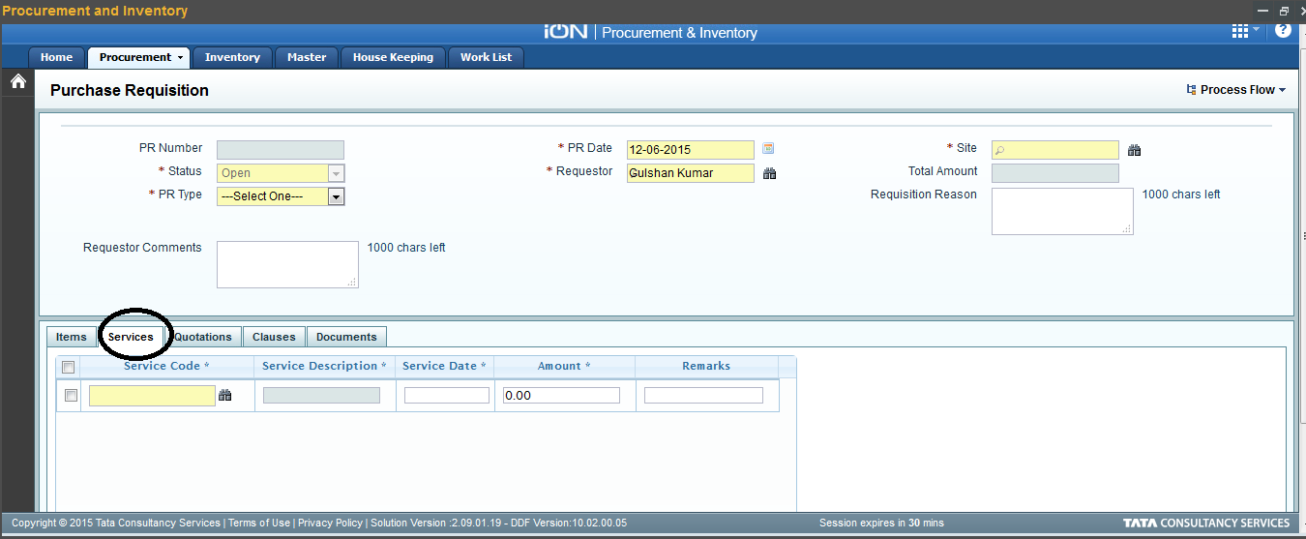

While raising PO, select services instead of items as shown below:
